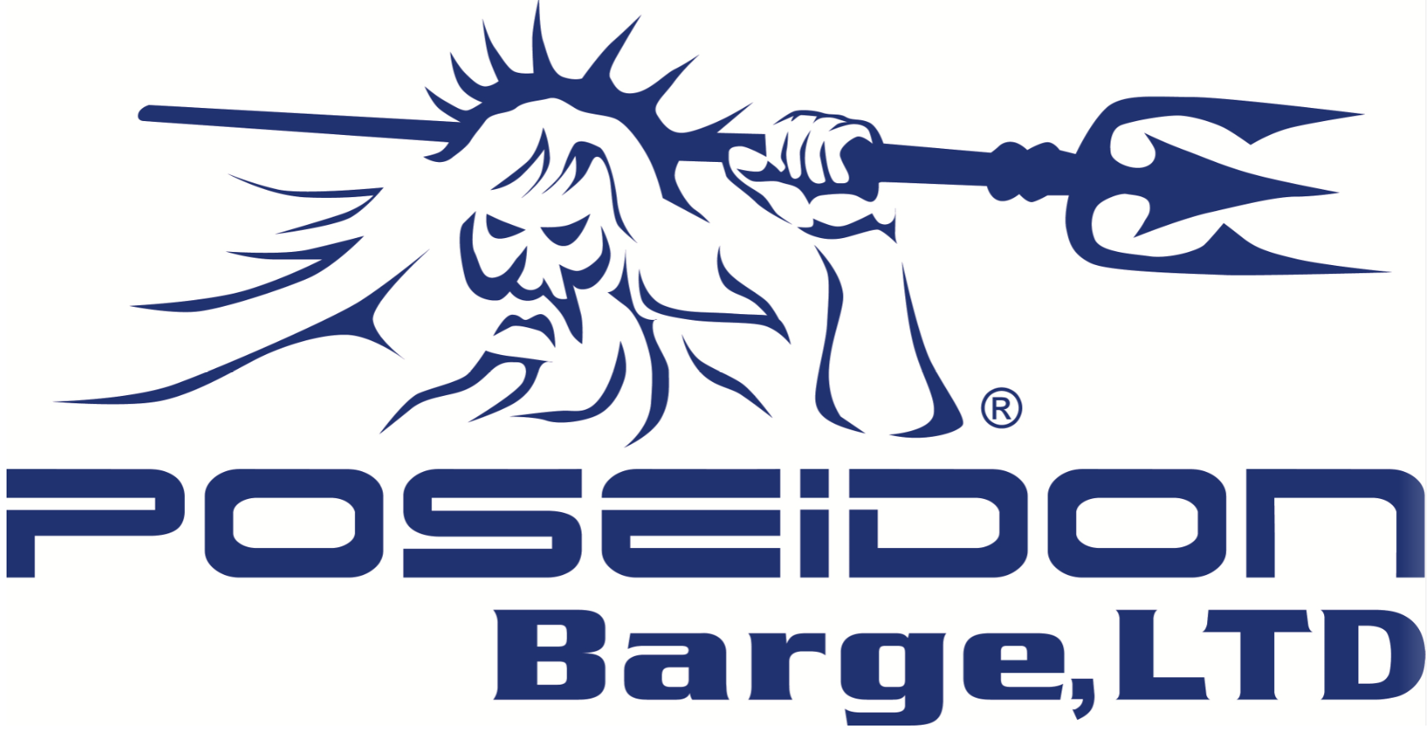

Supplier Quality Assurance Manual

Poseidon Barge, LTD
725 E Parr Road & 750 E Parr Road
Berne, Indiana 46711
USA

Suppliers:

Poseidon Barge, LTD is committed to supplying high quality, reliable and cost-effective portable sectional barges in a timely manner to our customers. Therefore, it is the goal of Poseidon Barge to form a partnership with its suppliers to ensure:
- Quality materials
- On-time delivery, and
- On-going price competitiveness throughout the supply chain.
Poseidon’s Quality Policy can be found on our web-site (https://www.poseidonbarge.com/poseidon-quality-policy/).

This Supplier Quality Assurance Manual is intended to ensure that all suppliers adhere to the quality, purchasing and delivery requirements of Poseidon Barge, LTD. It is based on, but not limited to, the internal operating systems of Poseidon Barge and the quality system requirements of ISO 9001:2015 and is intended to serve as a link between Poseidon Barge and our suppliers, both existing and potential.

Furthermore, the requirements of this manual describe a few of the minimum requirements that are placed on the supplier’s quality management system. It is designed to supplement the fundamental technical and organizational conditions that govern all deliveries and services and not replace or amend the terms and conditions specifically noted on purchase orders, engineering drawings, prints and/or specifications, agreements, or contracts.

We appreciate your cooperation, and if you have any questions please send them to purchasing@poseidonbarge.com.

This forms can be found on the Poseidon Barge web site (http://poseidonbarge.com).

TABLE OF CONTENTS

Quality System Requirements 4

Supplier Approval Requirements 4

Approved Supplier 5

Evaluation and Escalation Process 5

Request for Quote 6

Purchase Order 7

PPAP Requirements 7

Request for Change 7

Change Point Control 9

Supplier Change Identification 10

Evidence of Material Properties 10

Receiving Inspection, Containment and Corrective Action 11

Poseidon Corporation Owned Property 11

Quality Systems Requirements

Poseidon Barge is a manufacturer of portable sectional barges and welded assemblies used in bridge construction, general marine construction, dredging, and other construction projects. Our aim is to enhance customer satisfaction through effective application of a quality management system with a focus on continual improvement and assuring the conformance of supplied product to our customer’s requirements and/or regulatory requirements.

Our suppliers of related material and components should be registered by an accredited 3rd party certification organization to the current ISO 9001 standard. Otherwise, a quality system must be implemented and verified. Upon review of Self-Evaluation (SUP-002), a Poseidon Barge representative may elect to schedule a supplier audit to assure all requirements are met.

No business can be placed with a new supplier prior to them being placed on our Approved Supplier List.

Supplier Approval Requirements

Before becoming a supplier of components or material, the Supplier Evaluation Profile (SUP-002) must be completed and returned. Then, the Purchasing Manager will complete the Supplier Risk Assessment (SUP-004), pending approval of the Quality Manager. Once accepted your company will be added to our Approved Supplier List. The acceptance process involves the determination that your company meets the following criteria:

- A Quality Management System is in place. This can be shown by:
- Certification to the current ISO9001 standard by an accredited third-party certification body, or
- Being a customer-specified supplier of one or more of our customers for the specific component or material required and/or audit by a Poseidon Barge representative to ensure compliance to the customer requirements.
- A deviation to the Supplier Approval Process may be granted through a formal process if necessary to procure material in order to maintain adequate supply for operations. In this event, form SUP-005 Material Deviation Approval Form will be used to document this deviation.

- A PPAP can be submitted.
- Test reports and certifications can be supplied (as required).

Copies of documents required must be supplied upon request.

Approved Supplier

To maintain Approved Supplier status, a supplier is one who has met the requirements criteria must also:
- Be fully responsible for all aspects of controlling quality and delivery of product supplied. This includes but is not limited to the product:
- Meeting the requirements of the purchase order, including the product quality expectations and requirements specified in this manual.
In addition, the supplied product must be:
- Clearly labeled,
- Packaged to prevent damage during transit, and
- Delivered on time
- Ensure that all certifications and other required documentation is available,
- Be responsible for ensuring that any sub-supplier understand and meet Poseidon Barge requirements and expectations.

Evaluation and Escalation Process

Poseidon Barge evaluates supplier performance annually by means of a rating system. The supplier evaluation details supplier performance in Delivery, and Quality. In the event of an unsatisfactory rating, the supplier status may be downgraded from “Approved” to “Needs Re-evaluated” or the worst case of “Disqualified”. Once graded “Disqualified” a supplier will be blocked from quoting on new business. Suppliers failing to achieve and maintain the “Approved” status may be required to develop a plan to correct performance.

If a supplier feels that their performance has deteriorated, it is their responsibility to confirm their rating by contacting the Poseidon Barge Purchasing Department.

The change of the status of a Supplier and escalation may include:
- Performance measurements which fail to meet On-time delivery, and quality levels as determined by Poseidon Barge.
- Failure to submit corrective action reports,
- Product exhibits a deterioration of product quality through an increase in PPM or increase of trouble incidents that results in line downtime, and

Annual performance evaluations will be comprised of:
- Delivery (on-time) - On-time delivery rating is based on the number of Late shipments on average per month received within the specified time-period window. This window is the expected delivery date. Any delivery after this date will be counted as NOT on-time. Scores range from 0 to 5. A 5 correlates to all deliveries being on-time and a 0 equates to 5 or more late shipments in a month.
- Quality (Non-conformances) – Nonconformances (NCs) are counted as any defect to quality or packaging of product that results in an adverse effect to Poseidon. Scores range from 0 to 5. A 5 correlates to all no NCs and 0 equates to 5 or more NCs in a month.
- CAR (Corrective Action Report) Responses – Supplier will be reviewed upon response time and completeness of CARs. Scores are 0 - Does not complete CAR, 3 - Late Response & Complete, and 5 - On-Time & Complete. When no CARs were requested, result will be Not Applicable (N/A)

Supplier Evaluation is the average score of Delivery, Quality and CAR Response, with results below:
Score | Average Score Results | Average Score Meaning
5 | Approved | Supplier Maintains Excellent Performance
4 | Approved | Supplier Maintains Satisfactory Performance
3 | Needs Re-Evaluated | Supplier Needs Re-evaluated in 6 months
2 | Needs Re-Evaluated | Supplier Needs Re-evaluated in 6 months
1 | Disqualified | Supplier Needs Disqualified
0 | Disqualified | Supplier Needs Disqualified

Request for Quote (RFQ)

A request for quote will be solicited by Poseidon Barge. This will be the only quote that will be considered for acceptance. The quote must:
- Be returned/delivered within 2 working days, unless an exception is granted,
- Be complete to print and specification requirements, and
- Offer competitive pricing.

The Supplier is responsible for:
- Understanding all the parameters of producing and supplying the product,
- Providing value added recommendations that affect production or shipping,
- Providing technical support, and
- Warranty costs directly related to the product, through the end-of life of the product.

If a quote has been accepted, a supplier may be required to submit a feasibility and project timeline. These documents become a method of determining if any special risks have been identified by the supplier which would necessitate a change in the project timing, or other considerations. These documents are completed on the supplier’s internal forms.

Purchase Order (PO)

All purchase orders will include:
- P.O. Number,
- Product being purchased (including but not limited to specific part number with revision level, process type and specification, and requirements for testing or approval, et al.),
- Quantity being ordered (or service required if quantity not applicable),
- Price, and
- Other contractual agreements, as required.

The general terms and conditions that comprise the supplier’s acceptance of the Purchase order can be found on the Poseidon Barge website (http://poseidonbarge.com).

Cancellation of a purchase order can be executed based upon the performance of the supplier, pricing issues, change in ownership, or bankruptcy. Should a supplier receive a cancellation notice, they shall have two (2) weeks to notify Poseidon Barge (through the Purchasing Department) in writing of any inventory for which they feel is the responsibility of Poseidon Barge. Failure to provide the written response will result in the supplier forfeiting any future claim associated with the PO defined by the cancellation notice.

Production Part Approval Process (PPAP)

Poseidon Barge requires, when necessary, suppliers complete a part submission using the Production Part Approval Process.

It is the responsibility of each supplier to ensure that all “dues dates” (request for quotes, PPAP submissions, corrective action reports, etc.) are met.

Request for Change

Since over the life of a part or product, changes in design, specification or processing may occur, the supplier shall request in writing all proposed changes to currently approved product, processes, materials and/or components in accordance with the purchase order and PPAP requirements prior to implementation. This includes, but not limited to:
- Design Changes
- New supplier of raw material (including chemicals) or components
- Material or Component change
- Method of control or inspection methods
- Method of manufacturing method or process
- Packaging
- Labeling
- Delivery
(For examples detailing these changes see table below in Change Point Control section)

Suppliers are solely responsible for controlling changes initiated at their location(s). Written authorization from Poseidon Barge must be obtained prior to incorporating any changes into production that may affect the fit, form and function of any supplied product or component. Request must be completed and forwarded to Poseidon Barge at least 30 days prior to introducing a permanent change.

If because of an emergency situation a change is to exist for a limited time, a request must be made to Poseidon for a temporary deviation. Temporary deviations will be tracked using form QF-016. This completed request should be forwarded to Poseidon Barge Purchasing Department. Production should not commence before approval is given. This approval can be verbal followed by an e-mail, but ultimately the return of the signed deviation to be kept as the record of the approval.

Change Point Control
The “Change Point Control” (CPC) system is a method to document a change to a part or process and to distinguish parts shipped from previously delivered orders. The following table outlines change types where CPC may apply:
Type of Change | Explanation/Example
Design change | The part drawing changes, altering the physical structure or number of the part. A design change is done when a new part drawing or a manufacturing instruction has been issued.  - New part design  - Design change that affects the part  - Design change that does not affect the part, such as part name or part number.
Material or Component change | The material or component used to manufacture the final part/product. This also includes any material used to manufacture any component used to assemble the final product.  - Material Composition  - Material Type  These will include raw material, oil, solder, epoxy, and other material deemed to affect functionality of the product.
New Supplier (of components or processing) change | A new supplier is one who has never produced the supplied material or component or contracted to provide a service, such as heat treat or paint.  - Addition of a new supplier,  - Change of supplier,  - Change of facility location,  - Change from in-house production to outside supplier (or vice-versa).
Manufacturing Process change | Any change to the processing steps that deviates from the original steps outlined in the approved PPAP, including changing a temporary process to become permanent (or vice-versa).  - Changing the order of processing steps,  - A special processing step.  - Parts sorted or inspected/certified and not detailed in the control plan.
Manufacturing Method change | A change to the method, setting, or condition used during the manufacture or assembly of the product that deviates from the original, approved PPAP.  - Change in machine location or after major repair.  - Machine or process setting change,  - Plating, welding, soldering or heat treat process changes,  - Change in normal control ranges (not routine adjustments),  - Operator change on a critical process.
Die or Mold or Jig or Tool change | The design of primary, secondary dies and/or molds including jigs are changed which potentially affects the quality, function, fit, appearance or reliability of the product.  - New die or mold,  - Modification to a die or mold (from original design),  - Welding or assembly fixtures,  - Cooling fixtures,  - Machine master for camshafts, pistons, or other parts,  - New or modified jigs or tooling.
Inspection Method change | The inspection method is changed which could affect a change in the quality performance of the product. This may require a PPAP resubmission.  - New or modified inspection equipment,  - Measurement methods or instrument type.
Shipping or Packaging change | The method of shipping/transporting parts or any change in the packaging that could affect the quality of the product.
Trail parts | A limited trial (not a normal production order) production was required.
Countermeasure | After a countermeasure was initiated.
New Production Parts | After any change to a part or process that results in a production of parts that differ from those previously supplied.
Other | As directed by Mursix Quality Department.

When suppliers are required to change the product or service supplied or receive an approved deviation to make any suggested change, they are required to have a Change Point Control (CPC) system in place. This system is a method to document a change to a part or process and to distinguish parts shipped from previously delivered orders. When used correctly, this CPC system will afford both Poseidon Barge and its suppliers with a documented approval record which correspondingly tracks changes and provides an accurate history of any change that has occurred to the parts or process. The supplier will also make information available, whether in the form of a Certification of Conformance, first article test result, or other means, to show Poseidon Barge that the change has occurred. This system will help ensure final product quality by providing a way to identify, approve and control change points which is necessary to safeguard the quality of finished products.

Records of the change must be maintained.

Supplier Change Identification

The Supplier will use some means to identify the initial shipment of components or product following the implementation of any one of the previously described change point conditions.

Evidence of Material Properties

As evidence of the consistency of the product supplied, the supplier must prepare certifications of conformance or analysis. These certifications shall include but not limited to certain characteristics, such as chemical composition, mechanical properties, process conformance and other attributes like appearance specific to the process or material supplied. If these characteristics are limited to a specific range, this range should be noted.

Receiving inspection, containment and corrective action requirements

To verify that shipments are defect free, Poseidon Barge may choose a number of methods to verify conformance which include:
- Analysis of the statistical data received,
- Evaluation of Certificates of Analysis (CofA) received,
- Evaluation by an independent laboratory,
- Inspection and/or testing of quality characteristics by random sampling with a c=0 acceptance criteria or 100% inspection, or
- Any agreed upon method.

In the event that a shipment is rejected, whether at time of receipt or during processing, the shipment will be quarantined, and the supplier will be contacted. At this point:
- a concession (deviation) can be issued for use of the material, with any additional costs associated with the use debited to the supplier, or
- the material or product returned for replacement, or
- the material or parts be sorted with the costs associated with the sort and discarded material/parts debited to the supplier.

Additionally, a supplier corrective action report (SCAR) may be issued which will require a structured investigation of the nonconformity and corresponding documentation reported to Poseidon Barge of the proposed corrective action to prevent recurrence.

An interim response submitted via e-mail is required within two (2) work days and the completed response, which address permanent corrective actions within two (2) weeks (14 calendar days).

Poseidon Barge Owned Property

Any Poseidon Barge property that is in a supplier’s control; such as, tooling, containers or intellectual property that is provided shall be identified and protected. If any become lost, damaged or found to have been rendered unusable, it is the responsibility of the supplier to maintain records and notify Poseidon Barge as soon as possible after the event was discovered.

References
- (Ref. QSP-8.4 Control of External Provision)
- SUP-002 Supplier Evaluation Profile
- SUP-004 Supplier Risk Assessment
- SUP-005 Material Deviation Approval Form

Document Change Summary
Revision | Revise Date | Author | Description
0 | 8/19/20 | G. Cox | New Document
1 | 8/18/21 | T. Fullenkamp | Highlighted in Yellow in Supplier Approval Requirements section

